**Sort command:**

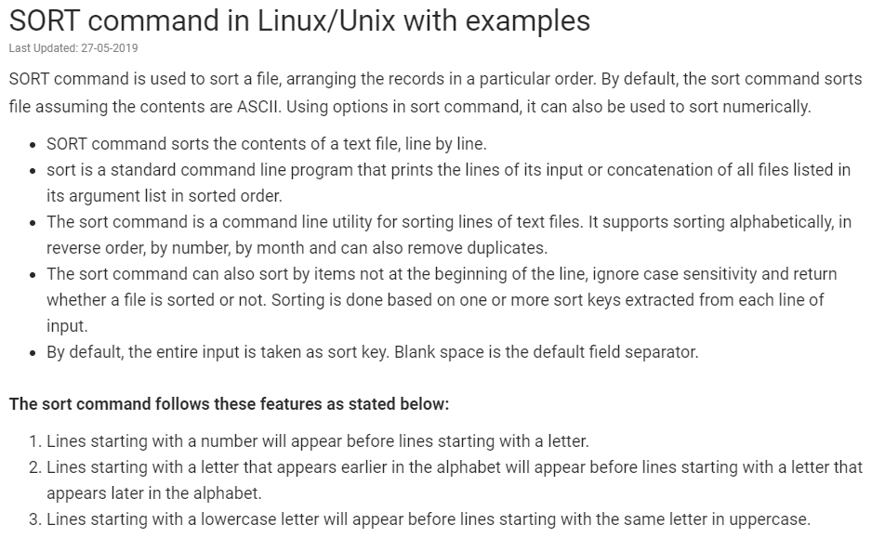

* Sort command is used to display the content of a file in an order without actually modifying the file. Above conditions apply

**Examples:**

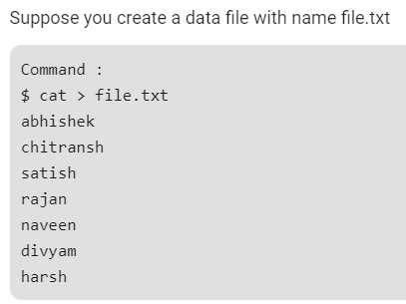

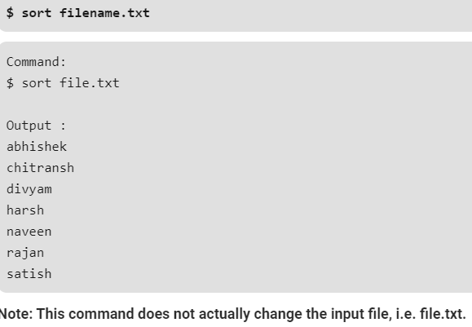

**Sort with lower and uppercase letters:**

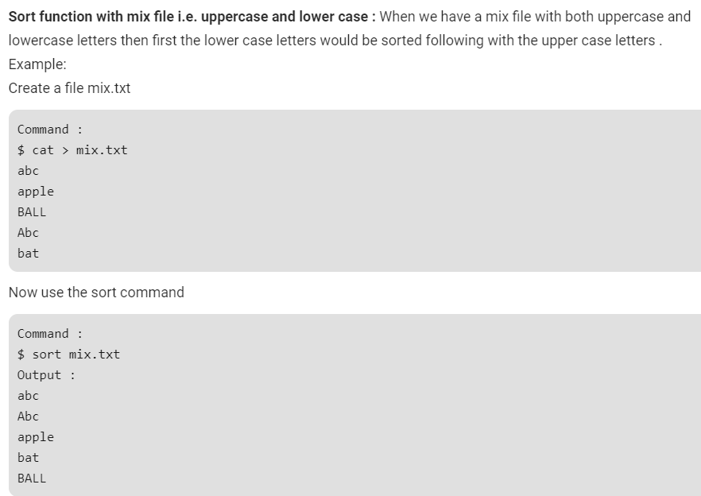

**-o Option :** Unix also provides us with special facilities like if you want to write the output to a new file, output.txt, redirects the output like this or you can also use the built-in sort option -o, which allows you to specify an output file.

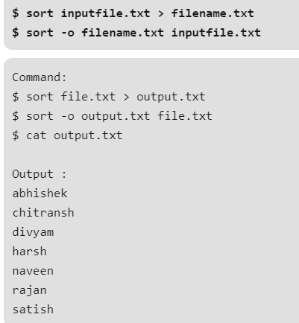

**-r Option:** Sorting In Reverse Order: You can perform a reverse-order sort using the -r flag. the -r flag is an option of the sort command which sorts the input file in reverse order i.e. descending order by default.

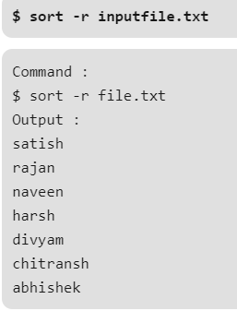

**-n Option :** To sort a file numerically used –n option. -n option is also predefined in unix as the above options are. This option is used to sort the file with numeric data present inside.

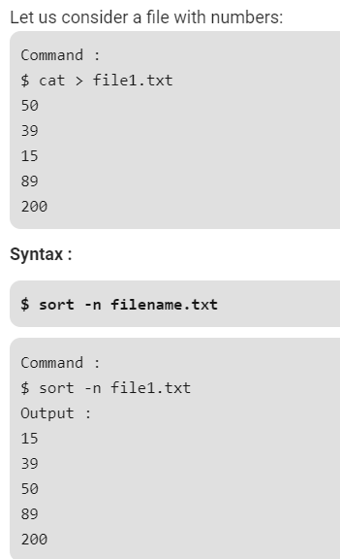

**-nr option :** To sort a file with numeric data in reverse order we can use the combination of two options as stated below.

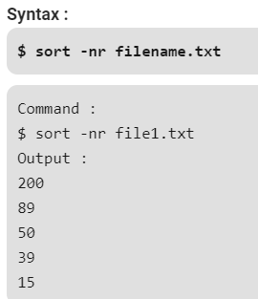

**-k Option :** Unix provides the feature of sorting a table on the basis of any column number by using -k option.

Use the -k option to sort on a certain column. For example, use “-k 2” to sort on the second column.

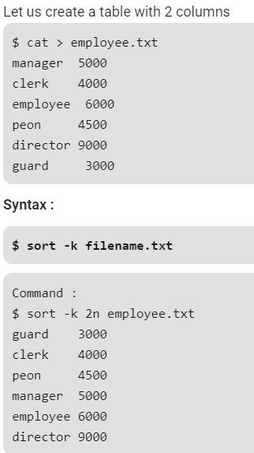

**-c option :** This option is used to check if the file given is already sorted or not & checks if a file is already sorted pass the -c option to sort. This will write to standard output if there are lines that are out of order.The sort tool can be used to understand if this file is sorted and which lines are out of order

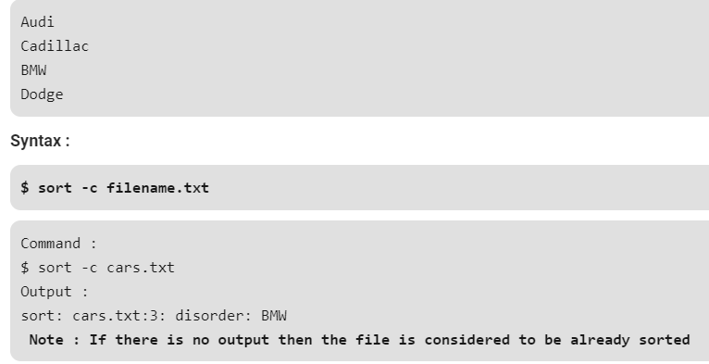

**-u option :** To sort and remove duplicates pass the -u option to sort. This will write a sorted list to standard output and remove duplicates.

This option is helpful as the duplicates being removed gives us an redundant file.

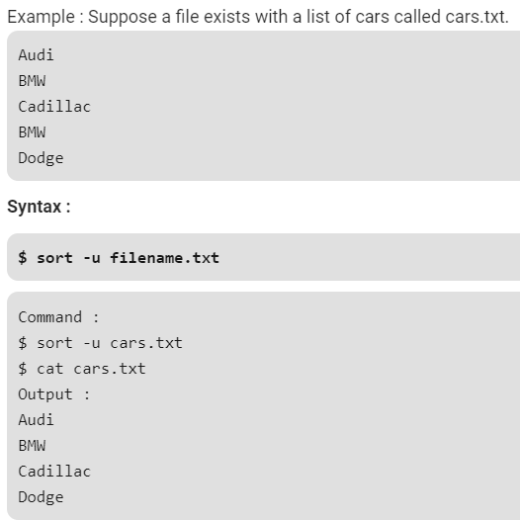

**-M Option :** To sort by month pass the -M option to sort. This will write a sorted list to standard output ordered by month name.

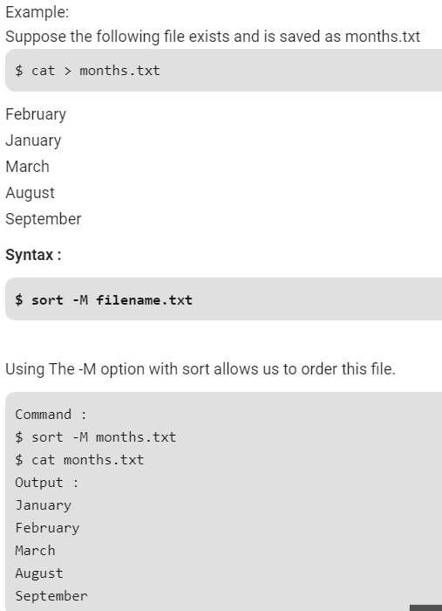

**Alias command:**

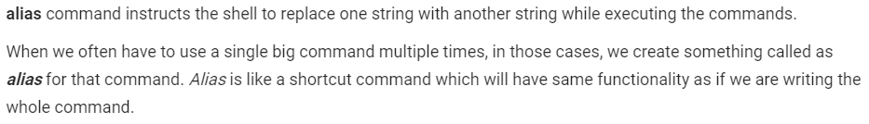

**Creating alias:**

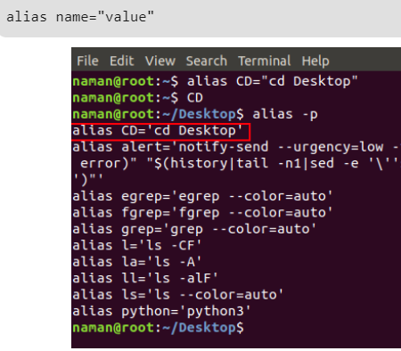

**Check for the defined aliases:**

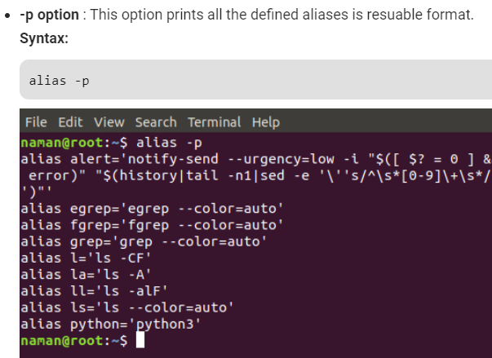

**Remove alias:**

* Unalias is the command to remove alias.

